Sample task document for the AI basics-1
1. Introduction to Artificial Intelligence
What is Artificial Intelligence (AI)?
Artificial Intelligence (AI) is a branch of computer science that enables machines to perform tasks that normally require human intelligence. These tasks include learning, reasoning, problem-solving, understanding language, recognizing images, and making decisions.
AI systems learn from data and improve their performance over time instead of following only fixed programming rules.
Examples
- ChatGPT answering questions
- Google Maps finding the fastest route
- Netflix recommending movies
- Face Unlock on smartphones
- Self-driving cars
Why AI is Important
- Automates repetitive tasks
- Improves productivity
- Helps make data-driven decisions
- Reduces human errors
- Enables smart applications

2. Types of AI (ANI, AGI, ASI)
2.1 Artificial Narrow Intelligence (ANI)
ANI is designed to perform a single specific task.
Characteristics
- Task-specific
- Cannot think beyond its programming
- Most AI systems today are ANI
Examples
- ChatGPT
- Siri
- Alexa
- Google Translate
- Recommendation systems

2.2 Artificial General Intelligence (AGI)
AGI refers to AI that can perform any intellectual task a human can do.
Characteristics
- Learns multiple tasks
- Understands context
- Can reason and solve new problems
Current Status
AGI does not exist yet. It is still an active research goal.

2.3 Artificial Super Intelligence (ASI)
ASI is a theoretical AI that surpasses human intelligence in every domain.
Characteristics
- More intelligent than humans
- Self-improving
- Capable of solving extremely complex problems
Current Status
ASI does not exist and remains hypothetical.
Large Language Model (LLM)
What is an LLM?
A Large Language Model (LLM) is an advanced Artificial Intelligence model trained on billions or trillions of words to understand, generate, summarize, translate, and reason over natural language.
LLMs use the Transformer architecture, which enables them to understand relationships between words in a sentence using an attention mechanism.
Examples
- GPT-4/GPT-5
- Gemini
- Claude
- Llama
- Mistral

LLM Architecture
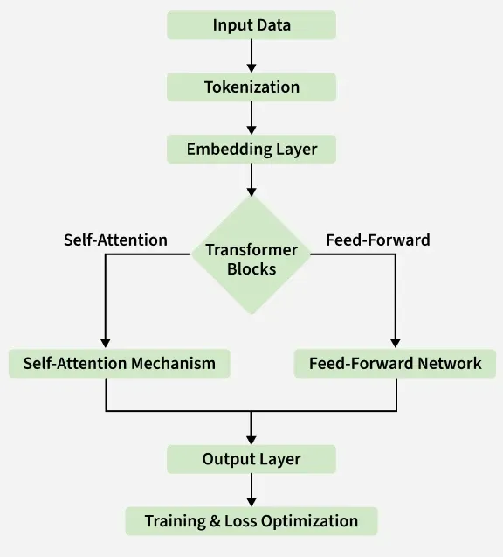
Components
1. Tokenization
Splits text into smaller units called tokens.
2. Embedding Layer
Converts tokens into numerical vectors.
The model understands numbers rather than text.
3. Positional Encoding
Adds position information so the model understands word order.
4. Transformer Layers
These are the heart of every LLM.
Each layer contains:
- Self Attention
- Multi-Head Attention
- Feed Forward Neural Network
- Layer Normalization
- Residual Connection

5. Output Layer
Predicts the next most probable token repeatedly until the answer is complete.
Applications
- Chatbots
- Translation
- Code Generation
Function Calling
What is Function Calling?
Function Calling allows an LLM to call external tools or APIs instead of generating everything from its own knowledge.
The model decides:
- Which function to call
- What parameters to pass
- Uses the returned result
- Generates the final response
Vector Database
What is a Vector Database?
A Vector Database stores information as embeddings (vectors) instead of plain text.
It helps AI find the most similar information quickly using semantic search.
Workflow
Documents
│
▼
Chunking
│
▼
Embedding Model
│
▼
Vector Embeddings
│
▼
Vector Database
(Pinecone, Chroma, FAISS, Weaviate, Milvus)
Retrieval-Augmented Generation (RAG)
What is RAG?
RAG combines:
- Retrieval from external knowledge
- LLM generation
Instead of relying only on its training data, the LLM retrieves relevant documents and uses them to generate accurate answers.
RAG Workflow
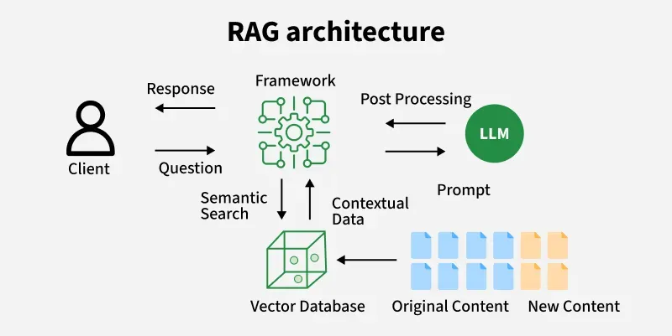
LangChain
What is LangChain?
LangChain is an open-source framework used to build applications powered by LLMs.
It connects LLMs with:
- APIs
- Databases
- Vector Databases
- Memory
- Agents
- External Tools

Chains
Connect multiple LLM steps.
Memory
Stores previous conversation.

Retrievers
Fetch documents from Vector Database.

Agents
Choose which tool to use automatically.

Applications
- Chatbots
- RAG
- Document QA
- AI Assistants
- Code Assistants

LangGraph
What is LangGraph?
LangGraph is a framework built on top of LangChain that enables developers to build stateful, multi-agent, and workflow-based AI applications using graph structures.
Unlike LangChain's linear chains, LangGraph allows loops, branching, conditional logic, retries, and complex workflows.
LangGraph Architecture
User
│
▼
Start Node
│
▼
Planner Agent
│
┌──────┴──────┐
▼ ▼
Search Agent Calculator Agent
│ │
└──────┬──────┘
▼
Review Agent
│
▼
Final Response
Features
- Multi-Agent Systems
- Stateful Workflows
- Parallel Execution
- Conditional Routing
- Human-in-the-loop
- Error Recovery
- Memory Support
- Email writing
What are AI Agents?
AI Agents are intelligent software systems that can observe, reason, plan, and take actions to achieve a goal, often with minimal human intervention.

AI Agent Workflow
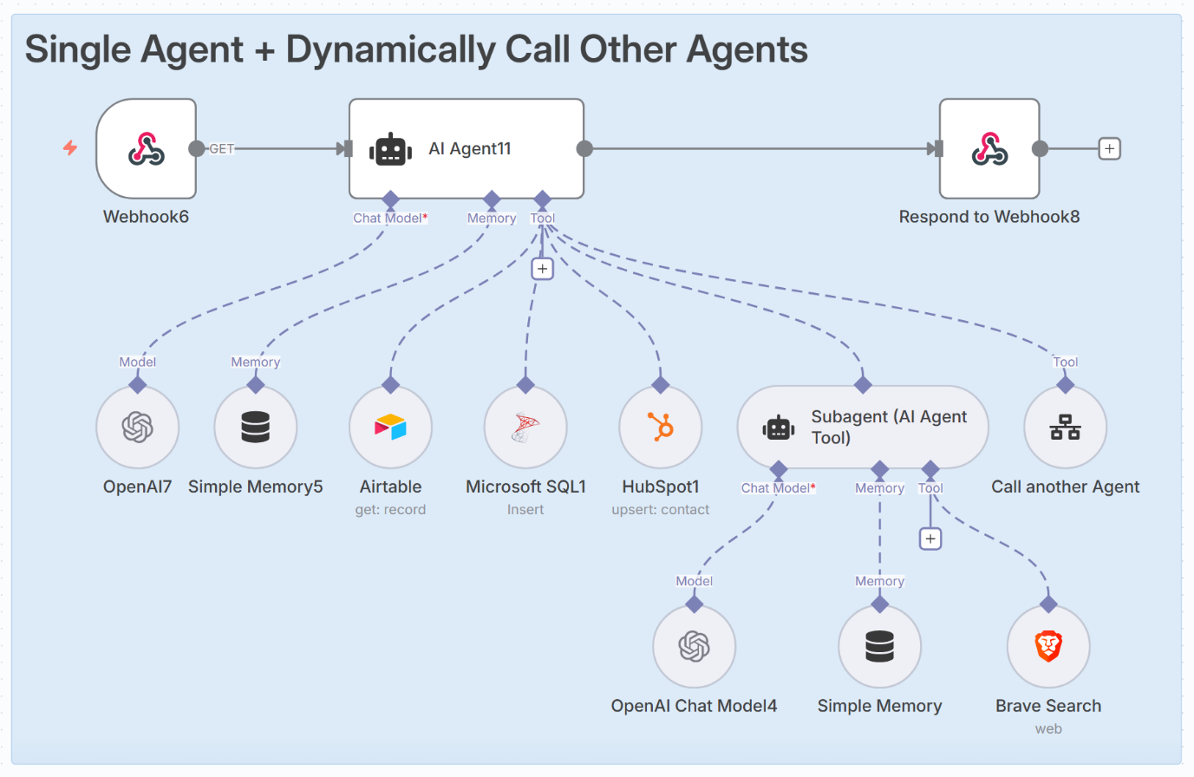
Examples
- Personal assistants
- Customer support bots
- Coding assistants
- Research agents
- Automation workflows
- n technology

Key AI Terminology (Glossary)
Term | Meaning
AI | Artificial Intelligence
ML | Machine Learning
DL | Deep Learning
Generative AI | AI that creates new content
LLM | Large Language Model
Prompt | Input given to an AI model
Token | Small unit of text processed by an LLM
Dataset | Collection of training data
Model | AI system trained on data
Training | Process of teaching an AI model
Inference | Using a trained model to make predictions
Neural Network | Brain-inspired computing model
Transformer | Deep learning architecture used in modern LLMs
Fine-tuning | Adapting a pre-trained model to a specific task
Embedding | Numerical representation of data
API | Interface for communication between software systems
AI Agent | AI system that can plan and perform tasks
Computer Vision | AI that understands images and videos
NLP | Natural Language Processing
Chatbot | AI system that interacts through conversation

Conclusion and Key Takeaways
Artificial Intelligence is transforming industries by enabling machines to perform intelligent tasks efficiently. Machine Learning and Deep Learning are subsets of AI that allow systems to learn from data, while Generative AI creates new content such as text, images, and code. Large Language Models (LLMs) power conversational AI applications, and AI Agents extend these capabilities by planning and executing tasks autonomously.
Key Takeaways
- AI enables machines to mimic human intelligence.
- ANI is the most common type of AI today, while AGI and ASI remain future goals.
- Machine Learning and Deep Learning are subsets of AI.
- Generative AI creates original content like text, images, and code.
- LLMs understand and generate natural language.
- AI Agents can plan, reason, and use tools to complete tasks.
- AI is widely used in healthcare, education, finance, manufacturing, agriculture, transportation, and cybersecurity.
- While AI offers significant benefits, challenges such as bias, privacy, and ethical considerations must be addressed for responsible use.

